TITLE OF MANUSCRIPT = TITLE OF WORKSHOP PRESENTATION
Authors' Names in Proper Order
Affiliations of Authors
Corresponding Author: Name, E-mail: xxx@yyy (If one author only, do not repeat name)
SUMMARY
This is the Microsoft Word template for your manuscript. Summary should not exceed 50 words. For consistency of the Proceedings, please adhere to this style and format. Please use INTRODUCTION and CONCLUSIONS for the first and last sections headings. Please do not alter margins, font type and size, line spacing.
Keywords: Most Typical, Up to five, Coma separated.
INTRODUCTION
The format is as outlined: Paper size: A4 (210×297mm). All margins (left, right, upper and lower): 25mm. Right upper heading with fixed Workshop text.
Title, Summary and Keywords: centered. Rest of text: justified. All text single line space, with 12 points spacing above headings and sub headings and 6 points spacing above first line of text in each paragraph.
Heading of first section should be INTRODUCTION. Heading of last section should be CONCLUSIONS, followed by REFERENCES.
Manuscript length should not exceed 2 pages.
Main body of extended abstract
Style in as follows: TITLE in bold capital ARIAL 13 points. The title of the manuscript should be identical to that of the workshop presentation. Authors' names in Arial 11 points. Affiliation of authors and E-mail address of corresponding author: Times New Roman 10 points. Group authors from same affiliation. Repeat corresponding author's name only if not clear otherwise.
The heading SUMMARY, as in the template, in bold capital ARIAL 10 points, with summary text in Times New Roman 10 points, not exceeding 50 words, followed by a list of no more than 5 Keywords.
All first order headings in bold capital ARIAL 10 points (single spaced with 12 point before). Text immediately below heading and all other paragraphs in Times New Roman 10 points (single spaced with 6 points before).
Sub Headings
Sub Headings in bold Arial 10 points with only first letter of each word capitalized (single spaced with 12 point before). Text immediately below sub heading and all other paragraphs in Times New Roman 10 points (single spaced with 6 points before).
References should be addressed using last name and year of publication. If more than 2 authors, use et al. (Lee 2009, Feldman and Schneider 2008, Smith et al 2007).
Figures and Tables and their captions should be centered.
Table caption should be placed above table.
Table 1: Caption fonts are Times New Roman 10 points, single line spacing with 6 points before and after
 | Heading Column  (Units) | Heading Column  (Units) | Heading Column  (Units)
Heading Row
Heading Row
Heading Row
Heading Row
Headings in table should be in bold Times New Roman 10 points. Use SI units. Column Headings should be centered, Row headings should be "left".
Figure caption should be placed below figure. Add one blank regular text line between text and the figure that comes below it.

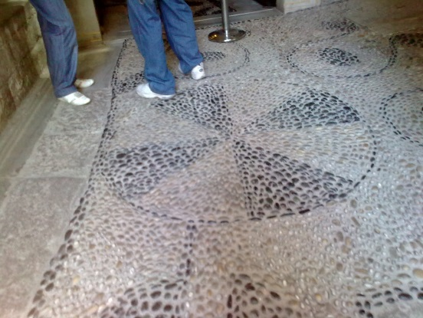
Figure 1: Caption fonts are Times New Roman 10 points, single line spacing with 6 points before and after
When citing figures or tables from others, please make sure to clarify it in the text, and point at the relevant reference in the caption as well.
Equations should be included in the text and numbered consecutively at the right-hand margin. Immediately below the equation add the required legend in a concise format, as demonstrated here:
a²+b²=c² (1)
Where: c is the hypotenuse of the triangle, and a and b are its other sides.
In the text, refer to equations as Eq.(x).
CONCLUSIONS
Please try to point out in this section what are the main routes for future research that have a potential for making a true leap forward in the area of sustainable buildings.
Please use your name to save the file of your manuscript, and submit the WORD and PDF files to the workshop secretariat by e-mail: sustain@tx.technion.ac.il not later than January 31, 2014.
ACKNOWLEDGEMENTs
Please use this heading and section only if f you need to acknowledge anyone.
REFERENCES
Please list by alphabetic order of last names, starting with last name and followed by initial(s) of first name(s). Supply complete details of journal, report and book references, as customary in scientific journals.

